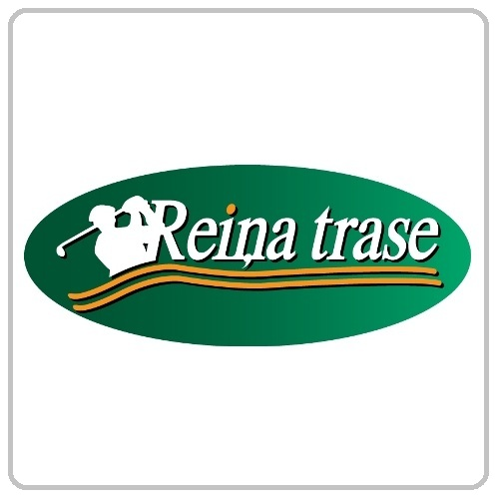

Reiņa Trase Golf Complex Price List.
www.reinatrase.lv

Green Fee
Mon - Thu Fri - Sun Green fee 9 holes Eur 15.00 Eur 22.00
Green fee 2x9 holes Eur 22.00 Eur 30.00
Green fee whole day Eur 30.00 Eur 40.00
Green fee 9 holes (junior) Eur 7.50 Eur 11.00
Green fee 2x9 holes (junior) Eur 11.00 Eur 15.00
Golf cart rent Eur 30.00 Eur 50.00

Driving range

Range token / junior Eur 3.00 Eur 1.50
Club rent/ junioriem Eur 1.50 Eur 0.75
Club full set rent / junioriem Eur 12.00 Eur 6.00
Trolley rent/ juniori Eur 2.00 Eur 1.00

Valdis Liepins Club Pro

Lesson 50 min Eur 30.00
Lesson 1 h 50 min Eur 50.00
Group Lesson 1 h 50 min / 20 person Eur 200.00

Beginners

Green card course (10 h. 1 persons) Eur 200.00
Green card course (10 h. 2 persons) Eur 150.00/pp
Green card course (10 h. 3-6 persons) Eur 100.00/pp

Club members

Golf Season Card Eur 500.00
Golf Club Members Fee Eur 150.00

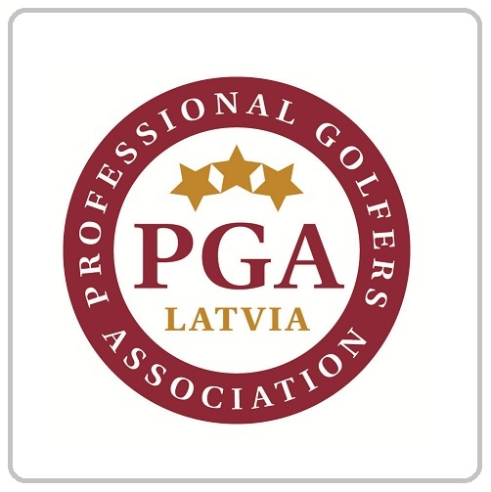

Golf in Latvia

To play on the golf course and
participate in competitions
you will need HCP .
HCP you can get
if you are passing Green Card Course
and HCP 54 regulations.

LGF HCP Card price:
Adults – 30,-EUR
Juniors – 10,-EUR

For more information about
Green Card Course.

Golf Club Pro
Valdis Liepins Tel. 29272767
www.golfshop.lv

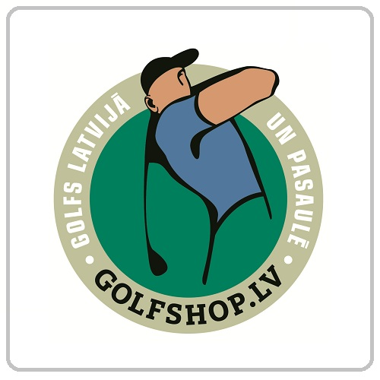
Green Card Course.

10-hour course and Green Card - 200, - EUR
2 persons 150, - EUR per person.
3-6persons 100, - EUR per person.

1st lesson: (1 h 50 min.) Driving-range and Course
Introduction and explanation of basic golf principles (game, clubs, course, stroke technique , and 1-3 holes on the course).
The cost of lesson 60 EUR Clubs and balls included.

2nd lesson: (1 h 50 min.) Driving-range and Course
Golf rules and etiquette and 3–6 holes on the course, Pro strategy and course management.
The cost of lesson 60 EUR Clubs and balls included.

Distribute Golf Beginners Card
(This card enables to play in Local Golf Course for continue Green Card courses)

3rd lesson: (1 h 50 min.) Stabilizing and Course
Swing technique stabilizing and 3–6 holes on the course, Pro strategy and course management.
The cost of lesson 60 EUR Clubs and balls included.

4th lesson: (1h 50 min.) Green Card exam.
30 min. Golf rules and etiquette test.
Practical and time test 6-9 hole on the course.
The cost of lesson 60 EUR Green Card, Clubs and balls included.
The cost of HCP Card 30 EUR

Info
1. Confirm your lesson schedule with Pro.
2. Maximum time for Green Card course - 4 weeks.
3. Golf Course provides all players with clubs and driving-range balls.

